
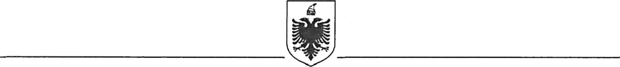
REPUBLIC OF ALBANIA
MINISTRY OF FINANCE
GENERAL DIRECTORATE FOR FINANCING ANND CONTRACTING OF EU, WORLD BANK AND OTHER DONORS FUNDS

Contract Award

Project Name: Western Balkans Trade and Transport Facilitation Project
Country: Albania
Project Number: TF No.: 8933-AL

Report Period: 24.09.2024

Awarded Contractor: | 2T Sh.p.k
Contractor’s Address: | Address: “Street Asim Vokshi, N.14 H.4 Ap.5, Tirana, Albania  E-mail: 2tshpk@gmail.com
Contract Signature date: | 17 September 2024
Method of Procurement/Selection: | Small Works
Price: | 2,789,975.64 EUR (Two million, seven hundred eighty-nine thousand, nine hundred seventy-five and sixty-four Euro)
Duration: | 17 September 2024 – 17 September 2025
Summary scope of contract: | Physical works at BCP Qafë Thana according to design.

